CSE-326

PROJECT SYNOPSIS



PROJECT NO. – 4

**SUBMITTED BY:**

ABHAY KUMAR MISHRA RK19RDB34

AYUSH SINGH RK19RDB35

MADDULA VENKATA MANOJ RK19RDB36

**INTRODUCTION**

We created this project with intention to automate the car-rental system to give user as well as the renter faster, convenient as well as easily manageable user-interface than manual task.

**Services provided to the user:**

* Registration/Login: In this system, we prompt the user to register first their details like their name, E-mail Id, Address/GPS location, Phone Number and password. After one time successful registration, user can login through their E-mail Id and password.
* Pre-Booking/Live Booking: User can pre-book the car by selecting the time and date for the cab service or have on-spot booking done through our system
* Booking confirmation: The user gets the booking confirmation through the SMS/E-mail with the details of the cab driver, his phone number and car number with a valid OTP
* Estimated Cost Price: The user gets the estimated cost price of the whole journey
* Car Selection: The user gets the option to select from the pool of different cars with details like the cost per km and estimated cost for the journey
* Car Pooling : The user gets the option to share the car with different users and thus less cost travel

**Services provided to the renter:**

* Details of the customer: The cab driver receives the address and name of the customer
* Car selection: The renter gets to know which car the user has ordered
* Cost of the journey: At the end of the journey the renter gets detailed report of the distance travelled and cost of the journey

**DATA FLOW DIAGRAM OF CAR RENTAL MANAGEMENT SYSTEM**

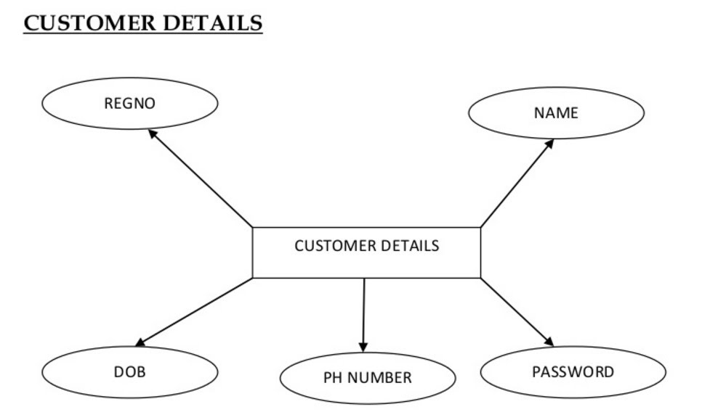

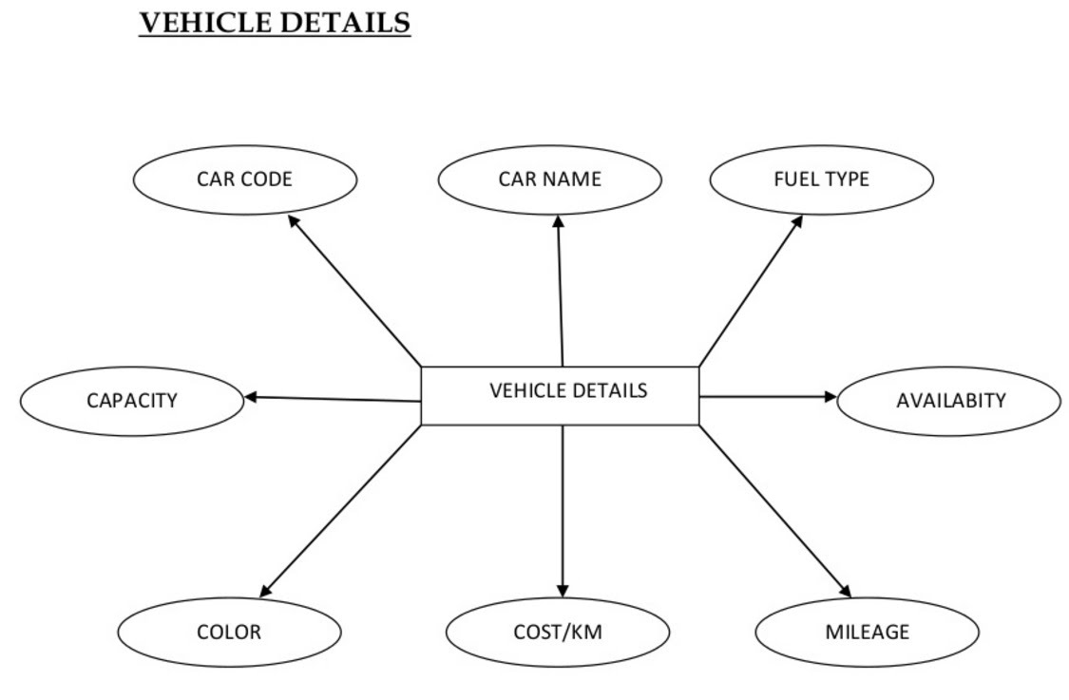

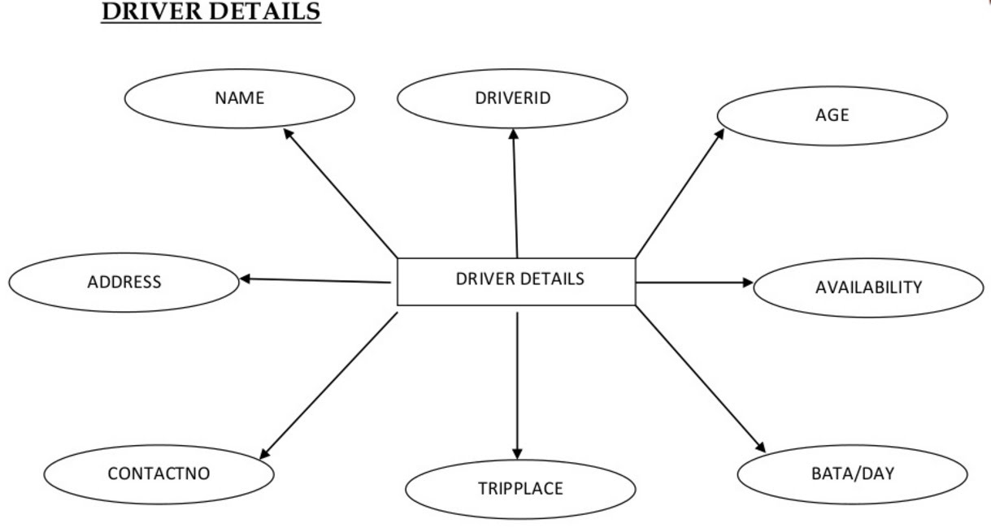

**GROUP MEMBERS**

ABHAY KUMAR MISHRA:

Manages homepage, about page, css for all pages, maps section

AYUSH SINGH:  
Manages css for all pages, contact page, forms, backend graphics

MADDULA VENKATA MANOJ:

Manages graphics and edits images, animation on website, menu section